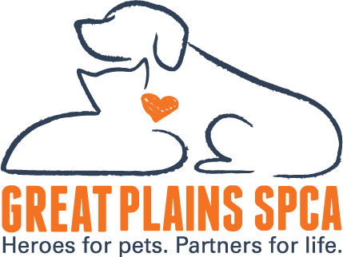

FOR IMMEDIATE RELEASE: February 3, 2025
MEDIA CONTACT: Tam Singer, CEO, Great Plains SPCA, (615) 578-3723, tsinger@greatplainsspca.org, Hathaway Maranda, Vice President of Philanthropy and Engagement 913-808-3296, hmaranda@greatplainsspca.org
Chiefs Kingdom Joins the Shelter Showdown: Can We Lead the Pack?
Kansas City, MO – Chiefs Kingdom, it’s time to rally once again! As the Kansas City Chiefs head to the Super Bowl, Great Plains SPCA is gearing up for an epic rematch in the Shelter Showdown Challenge Part II! This friendly fundraising competition pits our shelter against PAWS (Philadelphia Animal Welfare Society), representing the Philadelphia Eagles. While they’ve kicked off a $15,000 match campaign, we’re bringing the heat with our very own “Threepeat” Match Challenge!

A Three-Day, Threepeat Challenge!
Starting Thursday, February 8, three anonymous donors have pledged to match all donations, doubling every dollar given:
- Thursday: $1,500 match
- Friday: $2,000 match
- Saturday: $4,000 match
That’s a total of $15,000 in matching funds to help Kansas City’s homeless pets! Every donation will go twice as far in providing medical care, shelter, and second chances for animals in need.

ALSO - Support Great Plains SPCA & Bring Home a Champion!
Chiefs fans can show their support in two ways:
- Donate to Great Plains SPCA at www.sheltershowdown.org and help us take the crown in this nationwide challenge.
- Adopt your tailgate partner! Now through Super Bowl Sunday, we’re offering $15 adoptions for all dogs over 30 pounds. Show up in your Chiefs gear and take home a four-legged MVP!

Why This Matters
Last year’s Shelter Showdown was a game-changer, raising crucial funds for shelter pets. This year, we’re stepping up our game to prove that Chiefs fans lead with heart both on and off the field. Let’s outmatch Philadelphia and show the nation that Kansas City stands behind its animals!

Join the Challenge
The Shelter Showdown is more than a competition—it’s a chance to make a real difference. Donate, adopt, and spread the word. Together, we can score a Super Bowl-sized impact for pets in need!

Let’s Go, Chiefs Kingdom!
About Great Plains SPCA
Great Plains SPCA is one of the largest animal shelters in the Kansas City area serving 6,800 community pets annually. Great Plains SPCA works to save, protect and improve the lives of animals, while strengthening the relationship between pets and their human companions by providing humane sheltering, adoptions, community outreach and behavior training. Great Plains SPCA is a 501(c)(3) non-profit organization. For more information, please visit www.greatplainsspca.org or follow us on Facebook, Instagram and Twitter.

