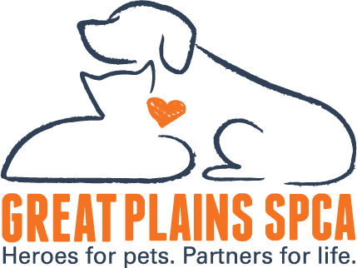

FOR IMMEDIATE RELEASE: January 23, 2025
MEDIA CONTACT: Tam Singer, CEO, Great Plains SPCA, (615) 578-3723, tsinger@greatplainsspca.org, Hathaway Maranda, Vice President of Philanthropy and Engagement 913-808-3296, hmaranda@greatplainsspca.org
Chiefs Kingdom Joins the Shelter Showdown: Can We Lead the Pack?
Kansas City, MO – Greetings from Chiefs Kingdom! As the Kansas City Chiefs charge toward another Super Bowl appearance, Great Plains SPCA is thrilled to announce its participation in the Shelter Showdown, a friendly fundraising competition uniting animal shelters from the cities of the final four NFL teams. This year, we’re representing Kansas City as proud Chiefs fans and passionate animal advocates, rallying our community to support local pets in need.
The Shelter Showdown brings together three incredible organizations:
- Great Plains SPCA (Kansas City Chiefs Kingdom)
- SPCA Serving Erie County (Buffalo Bills Mafia)
- Philly Paws (Philadelphia Eagles fans)
Each shelter is rallying its fan base to raise critical funds for their life-saving missions. The goal? To crown the ultimate fan base while making a difference for animals in our communities. This exciting initiative combines sports fandom with compassionate action and is a unique way to unite football and philanthropy.
$15,000 Mini Match for Kansas City’s Animals!!
Thanks to the generosity of an anonymous donor, Great Plains SPCA has already secured a $15,000 matching gift to kickstart our campaign. That means every dollar donated by Chiefs fans will have double the impact—helping us save more lives and provide essential care for homeless pets in Kansas City.
How You Can Help
It’s time for Chiefs Kingdom to show its spirit! Visit www.sheltershowdown.org to make your donation and help Great Plains SPCA pull ahead in the Shelter Showdown. Every donation brings us one step closer to victory for Kansas City and, most importantly, for the animals who depend on us.
A Proven Winner
Last year’s Shelter Showdown was a resounding success, raising significant funds and energizing communities across the country. With your help, we can top that success this year. Let’s show Buffalo and Philadelphia that Chiefs fans don’t just dominate the field—we lead with heart, too.
Join Us on the Road to the Super Bowl
Will Chiefs Kingdom come out on top both on and off the field? The countdown to the big game is on, and your support can make all the difference. Visit www.sheltershowdown.org today, donate, and share this opportunity to support Great Plains SPCA’s mission of saving lives, providing hope, and making a difference for Kansas City’s animals.
Let’s go, Chiefs Kingdom—together, we can make a Super Bowl-sized impact for animals in need!
About Great Plains SPCA
Great Plains SPCA is one of the largest animal shelters in the Kansas City area serving 6,800 community pets annually. Great Plains SPCA works to save, protect and improve the lives of animals, while strengthening the relationship between pets and their human companions by providing humane sheltering, adoptions, community outreach and behavior training. Great Plains SPCA is a 501(c)(3) non-profit organization. For more information, please visit www.greatplainsspca.org or follow us on Facebook, Instagram and Twitter.

