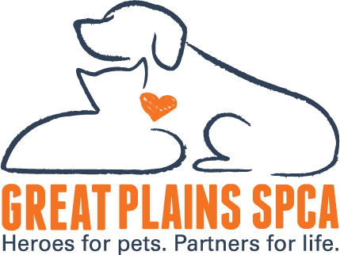

FOR IMMEDIATE RELEASE: January 24, 2025
MEDIA CONTACT: Tam Singer, CEO, Great Plains SPCA, (615) 578-3723, tsinger@greatplainsspca.org, Hathaway Maranda, Vice President of Philanthropy and Engagement 913-808-3296, hmaranda@greatplainsspca.org
Great Plains SPCA: Reflecting on 2024 – A Year of Challenges and Extraordinary Impact
[Merriam, KS, January 2025] – In 2024, animal shelters across the nation grappled with the intensifying pet overpopulation crisis. At Great Plains SPCA, we witnessed this firsthand as more families struggled to provide the care their pets needed. Yet, amidst these challenges, the unwavering generosity of our community created transformative outcomes for over 6,800 pets this year.
"2024 was a year of extraordinary challenges—and extraordinary impact," said Tam Singer, CEO of Great Plains SPCA. "Thanks to the dedication of our supporters, we were able to step up for pets and families when they needed us the most."

Remarkable Milestones of 2024
- 6,800 animals served in our community, a significant 1,800-pet annual increase in those served through our shelter and outreach programs.
- 2,206 animals were admitted to our facility, with an average length of stay, 27 days.
- 1,187 animals were adopted from Great Plains SPCA.
- Welcomed approximately 6,000 donors whose generosity raised over $2 million, fueling life-saving initiatives.

The Need Continues in 2025
While we celebrate these milestones, the need for compassionate care persists. With an average cost of $1,350 per pet at our shelter, the support of our community remains crucial. Families facing hardship depend on us to deliver critical resources, and pets in crisis count on us to find loving, forever homes.

A Call to Action for 2025
In the coming year, Great Plains SPCA is committed to:
- Finding more forever homes for pets in need.
- Delivering essential resources to families in crisis, ensuring pets can stay with the people who love them.
- Creating lasting change in our community through education, outreach, and advocacy.
"Behind every number is a story of resilience and love—a once-homeless dog now curled up in a forever home, a struggling family able to keep their beloved pet, a foster kitty blossoming into their true self," Singer shared. "These stories are made possible because of you—our supporters, volunteers, and advocates."
As we look toward 2025, we invite everyone to stand with us to make an even greater impact for pets and families.

Join Us
Together, we can transform lives—one pet, one family, and one community at a time.
About Great Plains SPCA
Great Plains SPCA is one of the largest animal shelters in the Kansas City area serving 6,800 community pets annually. Great Plains SPCA works to save, protect and improve the lives of animals, while strengthening the relationship between pets and their human companions by providing humane sheltering, adoptions, community outreach and behavior training. Great Plains SPCA is a 501(c)(3) non-profit organization. For more information, please visit www.greatplainsspca.org or follow us on Facebook, Instagram and Twitter.

